Tips for viewing an eScription Event

When you first load the event page, you will be prompted with a Security Warning (Internet Explorer)

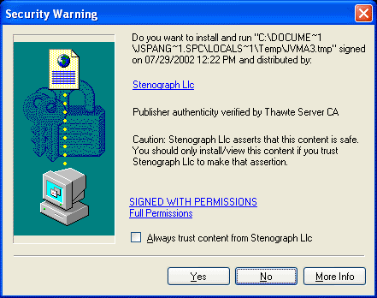

or 4 Java Security windows (Netscape)

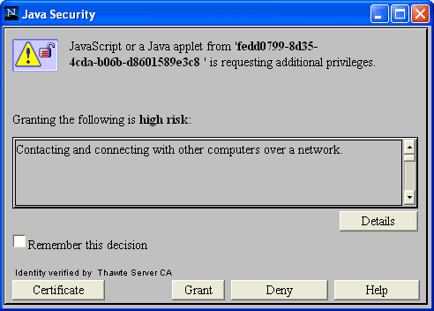
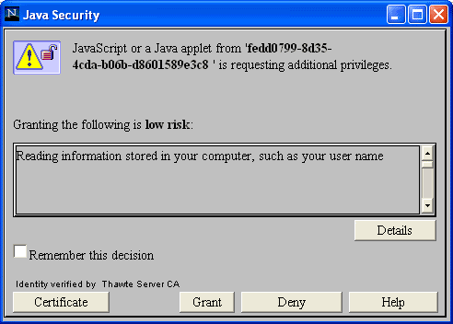

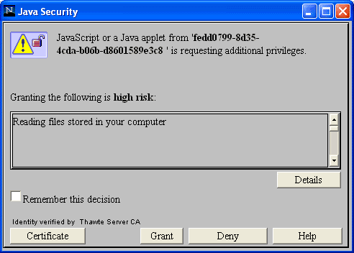

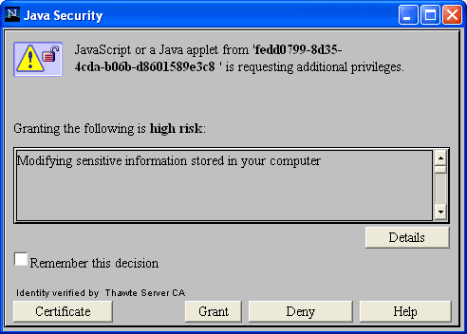

The reason for this is because our text display mechanism is attempting to check your machine’s firewall settings and it needs to make a connection across the Internet back to our Text Broadcaster. Thanks to hackers and people who write nasty viruses, these actions have been deemed high risk and require confirmation from the user (you) before they can take place. If you do not click the YES button on the Security Warning message (Internet Explorer) or GRANT on the Java Security windows (Netscape), you will NOT be able to see the captions for the event.

If you followed these instructions and you still do not see scrolling text for the event, please see our Troubleshooting Guide for further assistance.

C.A.R.T. eScription Events

When viewing a C.A.R.T. eScription event, there is a chat window displayed along with the normal text display. The chat window allows for communication between the captionist and viewer(s). This chat window can sometimes appear over the Security Warning (Internet Explorer) or Java Security windows (Netscape) mentioned above.
If you encounter the following situation:
- You have not seen the afore mentioned security window(s).
- Your Chat Window is open.
- The text display area remains a dull grey in color.
Please move the Chat Window to another part of your screen.
To move the Chat Window:
- Place your mouse pointer over the title bar at the top of the window.
- Hold down your left mouse button with the pointer over the title bar.
- Drag the Chat Window to a new location by moving your mouse while holding down the left mouse button.

On some systems, the chat window can take as long as 30 seconds to load. This is due to our chat server verifying your connection before it allows you to enter chat. Some computer and/or network configurations cause this process to take an inordinate amount of time. We are working to improve this process in future versions of the eScription platform.

